Module 03 Activity – Javascript Function and Number Reversal

Tracy Brevig

Rasmussen College

COURSE#: W110/COP1801 Section 01 Javascript

Instructor’s Name: Kimberly Powell

February 25, 2021

**Screenshots of the loaded pages:**

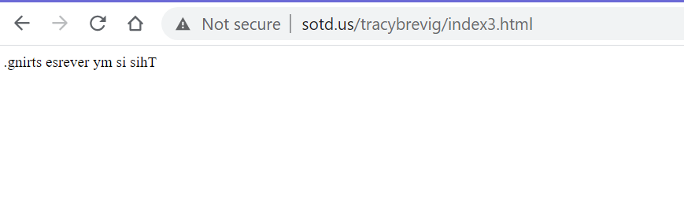

**Screenshot from atom displaying output:**

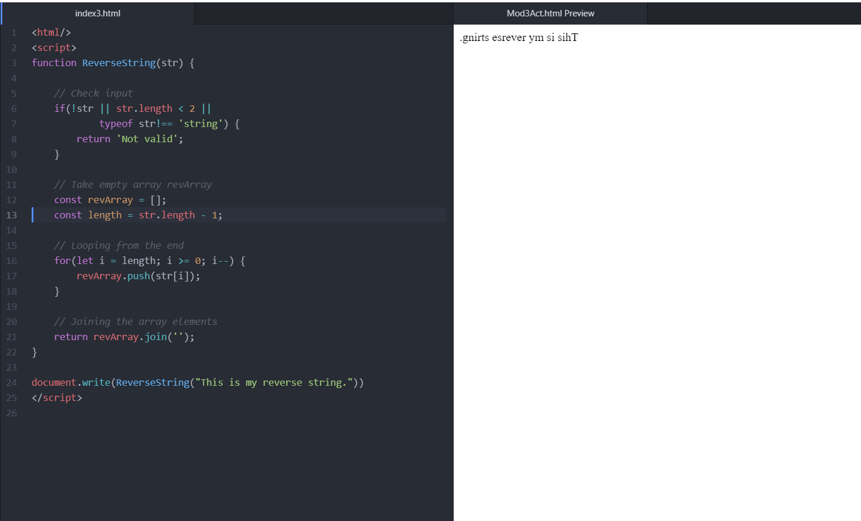

URL Link

<http://sotd.us/tracybrevig/index3.html>